16.26: a) 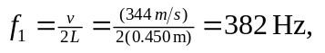 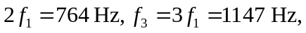 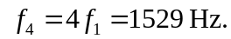
b) Note that the symbol “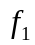” denotes different frequencies in the two parts. The frequencies are not always exact multiples of the fundamental, due to rounding.
c) Open: 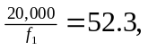 so the 52nd harmonic is heard. Stopped; 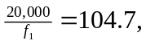 so 103 rd highest harmonic heard.

